Class 1 Example Kommineni

This is an [R Markdown](http://rmarkdown.rstudio.com) Notebook. When you execute code within the notebook, the results appear beneath the code.

Try executing this chunk by clicking the *Run* button within the chunk or by placing your cursor inside it and pressing *Cmd+Shift+Enter*.

# shows the data of cars in scatter plot   
plot(cars)

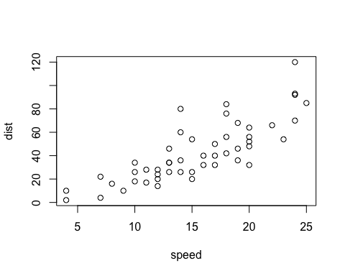

I can see a pattern in the data as stopping distance increase consistently with speed.

This is expected because higher speeds require more braking force and time to come to a stop.

The most amount of data in the region of speed 10mph and 20mph and distance of 20ft and 60ft

#x

Add a new chunk by clicking the *Insert Chunk* button on the toolbar or by pressing *Cmd+Option+I*.

x <- 2*8  
#I have create a variable x and stored a value of 2*8 in it   
x

## [1] 16

#I called the variable

When you save the notebook, an HTML file containing the code and output will be saved alongside it (click the *Preview* button or press *Cmd+Shift+K* to preview the HTML file).

The preview shows you a rendered HTML copy of the contents of the editor. Consequently, unlike *Knit*, *Preview* does not run any R code chunks. Instead, the output of the chunk when it was last run in the editor is displayed.